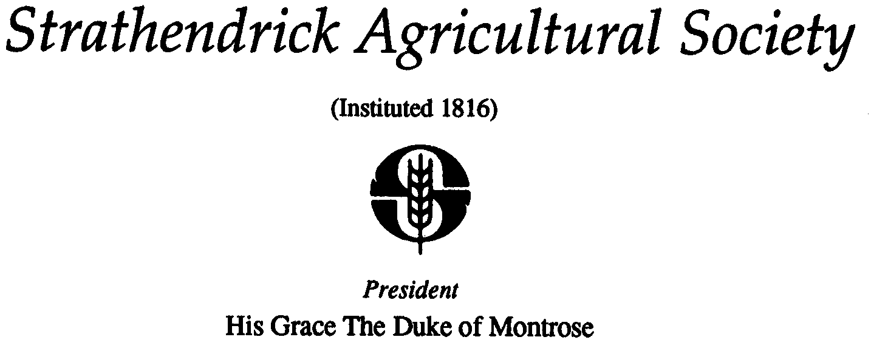

DATA PROTECTION – REQUEST TO STAY IN CONTACT

Strathendrick Agricultural Society would like to stay in contact with you. To comply with the new GDPR consent requirements, we need you to confirm that you would still like to hear from us.
We at Strathendrick Agricultural Society want to assure all our members and contacts that we handle your data professionally, securely and in accordance with these new regulations. (Please refer to our Privacy Policy on our web site www.drymenshow.com for more details.)
We currently hold your name and some contact details e.g. address, telephone number and email address. We use this information to send you details about events that the Society are holding and other Society matters. We do not sell your contact data or pass on any details without your consent. We are not intrusive with our communication and hope we can stay in touch.
We would be grateful therefore if you could either
- tick the consent box on the form you are being asked to fill out by one of our convenors (trade / craft stand, sponsorship, membership, entry to classes etc)
- complete this form with the details below and either return to the associated convenor in person or using their postal / email addresses or return to our Secretary; by post (Secretary, Strathendrick Agricultural Society, Keirhill Farm, Balfron, G63 OLG) or email (david.keirhill@btconnect.com)
In doing so you will be confirming you are happy for us to stay in contact and to ensure if you are that we have your most up to date contact details.
Unfortunately, if you do not confirm we will no longer be able to contact you.

THANK YOU FOR YOUR SUPPORT

REQUIRED FIELD – NAME

REQUIRED FIELD – EMAIL ADDRESS:

OPTIONAL FIELD - TELEPHONE / MOBILE NUMBER:

OPTIONAL FIELD - EMAIL ADDRESS:

